**GLOBAL SUPERSTORE DATA ANALYSIS REPORT**

**BY : VISAKH.D**

**INTRODUCTION**

This report provides an overview of the Global Superstore Dashboard developed using Power BI. The **Global Superstore dataset** simulates a real-world business scenario for a multinational retail company that sells a wide variety of consumer products across different regions and customer segments.

This dataset is widely used in data analytics and business intelligence education and practice due to its depth, diversity, and real-world relevance. Companies today generate massive volumes of data through their day-to-day operations, and leveraging this data effectively can provide a critical competitive advantage.

This Power BI project transforms raw data into meaningful insights that help uncover sales trends, customer behaviors, and operational efficiencies. Through dynamic dashboards, the report assists decision-makers in identifying growth opportunities and performance gaps.

**DATA DISCRIPTION**

The dataset is divided into three primary tables:

**Orders Table:** Contains information about individual orders placed by customers. It includes details such as Order ID, Order Date, Ship Date, Customer ID, Segment, Country, Market, Product Category, Sales, Quantity, Discount, Profit, and Shipping Cost.

**People Table: The** table mapping managers or sales representatives to regions. This helps to analyze performance or responsibility by region or market.

**Returns Table:** The table that identifies which orders were returned by customers. This table contains: Returned, order Id, Market

• Orders Table - 51,290 rows, 24 columns.

• People Table - 13 rows, 2 columns.

• Returns Table - 1,173 rows, 3 columns.

**Key columns :**

• Order ID: Unique identifier for each order

• Order Date & Ship Date: Dates of order placement and shipment

• Product ID,Product Name, Category, Sub-Category : Product classification

• Sales, Profit, Quantity, Discount : Discount metrics

• Ship Mode, Region, Country, City : Shipment and location information

**Dataset Overview**

**Industry : E-Commerce/Retail**

**Scope : Global (Multiple Regions and147 Countries)**

**Period : 2011-2014**

**Data Format : Excel (tabular,csv)**

**Data Profile**

The Global Superstore dataset is clean, well-structured, and contains minimal missing or null values in key fields. Essential columns like Order ID, Order Date, Customer ID, and Sales are complete and consistently formatted. Categorical fields such as Segment, Region, and Ship Mode have limited, standardized values, making filtering and grouping easier. Numerical fields like Sales and Profit are properly distributed, with negative profit values indicating loss-making transactions. Overall, the dataset is ready for analysis with clear patterns and reliable data quality.

**Key Measures (KPIs)**

• **Total Orders**

• **Total Sales**

• **Total Profit**

• **Total Quantity**

• **Top-Selling Product**

The Key Performance Indicators (KPI’s) and the Measures taken for this project.

**Data Transformation**

* **Date Formatting:** Standardized to **DD-MM-YYYY** to maintain consistency across visuals.
* **Derived Columns:** Created new fields like:
* **Year** and **Month** from Order Date for time-based analysis.
* **Profit Margin** calculated as Profit ÷ Sales to evaluate profit efficiency.
* **Categorical Cleaning:** Ensured uniform naming for values in columns like Segment, Category, Region, and Country
* **Duplicate Handling:** Removed duplicate records by checking Order ID and Product Name

combinations.

* **Missing Value Handling:** Verified that essential columns (e.g., Order ID, Sales) are complete; any

invalid records were excluded.

* **Returns Merging:** Integrated return data with the Orders table for better insight into returned transactions.

**Data Modeling**

A **star schema** model was created in Power BI

**Fact Table:**

• **Orders** – Includes transactional data (Sales, Profit, Quantity, Discount, etc.)

**Dimension Tables:**

• **Customers** – Contains Customer ID, Customer Name, Segment, and Region.

• **Products** – Contains Product Name, Category, and Sub-Category.

• **Returns** – Contains Order ID and return status.

• **Dates** – A calendar table was created to support time-based metrics.

The model ensures separation between facts and dimensions, making the data model scalable, easy to maintain, and efficient for querying.

**Data Relationships**

Power BI relationships were established to link different tables and allow interactive analysis

• **Customer Info (Region)** ⟷ **People (Region**) – *Many to One*

• **Orders (Order Date)**  ⟷ **DateTable (Date)** – Many to One

• **Orders (Region)**  ⟷ **People (Region)** – Many to One

• **Returns (Market)** ⟷ **People (Region)** – Many to One

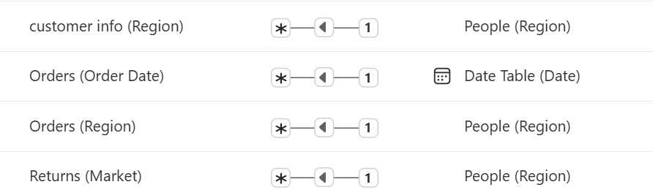

These relationships enable powerful cross-filtering across visuals

**Data Visualizations**

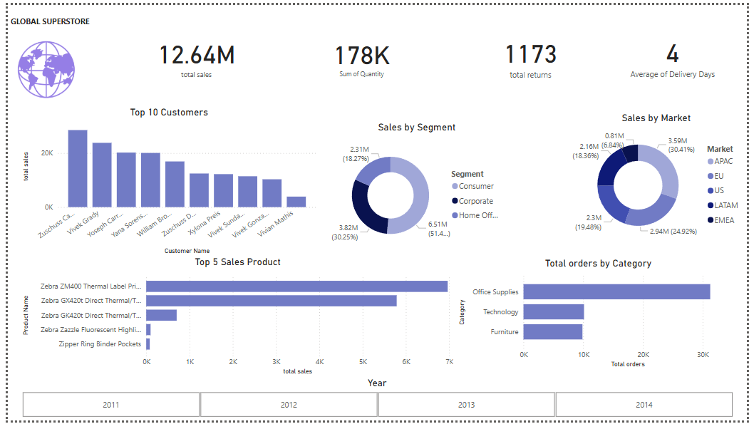

**The Global Superstore Dashboard consists of visual elements to represent the sale data effectively.**

**KPI’S**

• **Total Sales ( 12 .64M )**

• **Sum of Quantity ( 178K )**

• **Total Returns ( 1173 )**

• **Average Of Delivery Days ( 4 )**

These KPIs give a quick overview of the company’s performance in terms of revenue, volume, logistics, and return activity.

**Top 10 Customers by Sales**

•Visual Type: **Clustered Column Chart**

•This bar chart ranks the top 10 customers based on their total sales value.

• Key Observations:

•Customers like **Zuschuss Cus**, **Vivek Gandhi**, and **Joseph Carter** lead in total purchases.

•This chart is useful for understanding which clients drive the majority of revenue.

**Sales by Segment**

* Visual Type: **Donut Chart**
* Breaks down sales by customer segment:
  + **Home Office** – ₹6.51M (51.4%)
  + **Corporate** – ₹3.82M (30.25%)
  + **Consumer** – ₹2.31M (18.27%)
* This segmentation helps the business understand which group contributes the most to revenue and where to focus marketing or service improvements.

**Sales by Market**

• Visual Type: **Donut Chart**

• Shows the contribution of each geographical market:

* **EU** – ₹3.59M (30.41%)
* **EMEA** – ₹2.94M (24.92%)
* **LATAM** – ₹2.3M (19.48%)
* **US** – ₹2.16M (18.36%)
* **APAC** – ₹0.81M (6.84%)

• Helps identify regions with high or low sales volume and supports regional strategy planning.

**Top 5 Products by Sales**

* Visual Type: **Horizontal Bar Chart**
* Ranks products based on total sales:
  + **Zebra ZM400 Thermal Label Printer** is the highest-selling product.
  + Followed by **Zebra GX420t Direct Thermal Printers**.
* This insight helps with inventory planning and demand forecasting.

**Total Orders by Category**

* Visual Type: **Clustered Bar Chart**
* Compares the number of orders across major product categories:
* **Office Supplies** lead in order volume.
* Followed by **Technology** and **Furniture**.
* This helps in category-level performance analysis and marketing prioritization.

**Slicer**

* Visual Type: **Slicer by Year (2011–2014)**
* Allows users to filter visuals across the report by year.
* Useful for trend analysis, seasonal variations, and understanding growth over time.

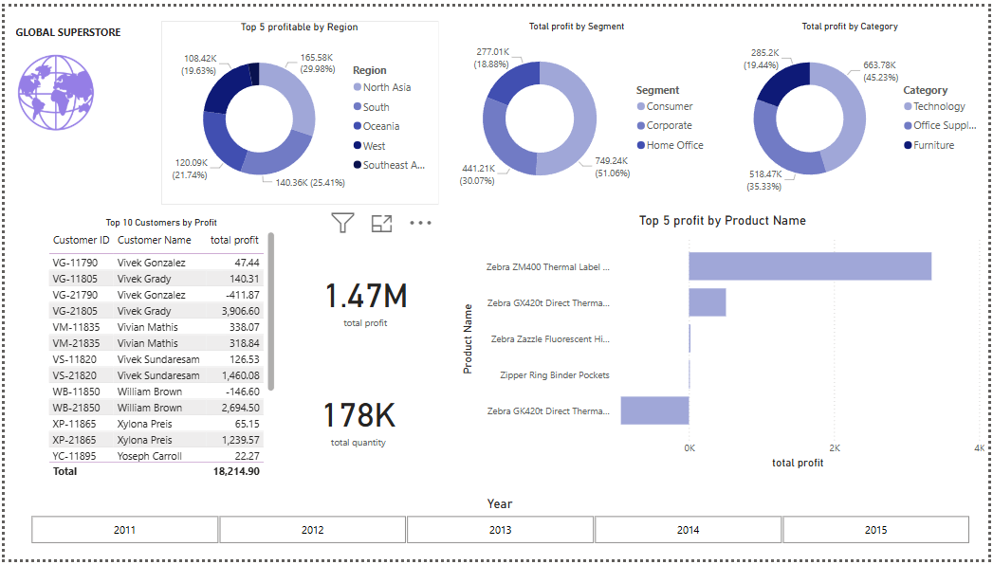

**The Global Superstore Dashboard consists of visual elements to represent the sale data effectively.**

**KPI’S**

* **Total Profit:** ₹1.47 Million
* **Total Quantity:** 178,000 units

**Top 10 Customers by Profit**

* Visual: *Table View with Bars*
* Includes customer IDs, names, and total profit contribution.
* Examples:
  + Vivek Gonzalez: ₹47.44
  + Vivek Grady: ₹140.31
  + Vivian Mathis, William Brown, and others.
* Helps identify high-value customers for retention strategies.

**Top 5 Most Profitable Regions**

* Visual: *Donut Chart*
* Profit by Region:
* North Asia: ₹165.58K (29.98%)
* Southeast Asia: ₹140.36K (25.41%)
* West: ₹120.09K (21.74%)
* South: ₹108.42K (19.63%)
* Oceania: Remaining %
* Supports geographical resource allocation and investment.

**Total Profit by Segment**

* Visual: *Donut Chart*

Segments:

* Home Office: ₹749.24K (51.06%)
* Corporate: ₹441.21K (30.07%)
* Consumer: ₹277.01K (18.88%)

Indicates that the Home Office segment not only drives sales but also profit.

**Total Profit by Category**

* Visual: *Donut Chart*

Categories

* Technology: ₹663.78K (45.23%)
* Office Supplies: ₹518.47K (35.33%)
* Furniture: ₹285.2K (19.44%)

Helps identify categories with better margin performance.

**Top 5 Most Profitable Products**

* Visual: *Horizontal Bar Chart*

Highest-profit products include:

* Zebra ZM400 Thermal Label Printer
* Zebra GX420t Direct Thermal Printer
* Others contribute marginally

Useful for SKU-level profitability analysis.

**Slicer**

* Used across both dashboards
* Allows filtering across multiple years (2011–2015)
* Enables dynamic time series exploration for sales/profit trends

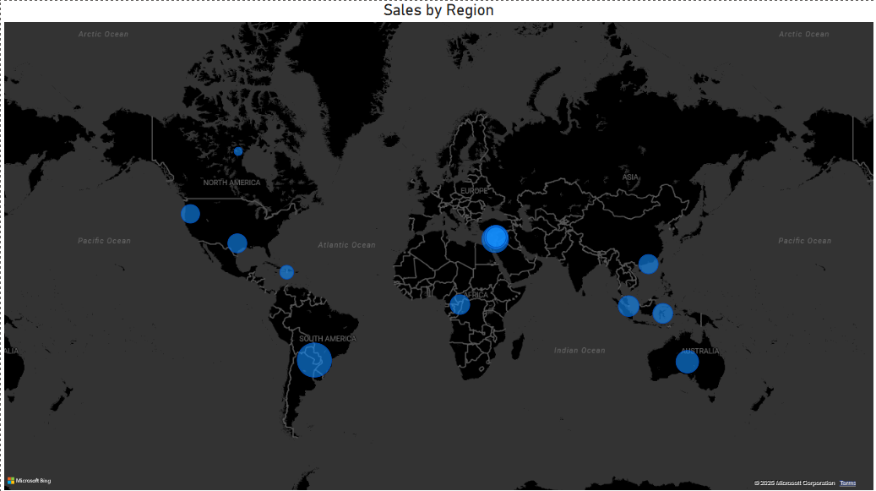

**Sales by Region (Map Visualization)**

* **Sales by Region (Map)**

The **Sales by Region** map visualizes global sales distribution using bubble sizes, where larger bubbles represent regions with higher sales. From the map, Europe and parts of Africa appear to generate the highest sales, followed by strong activity in Australia, South America, and Southeast Asia. This geographic insight helps identify top-performing markets and areas with sales potential.